

**SCHOOL OF** **COMPUTER SCIENCE AND ENGINEERING**

A Skill Development Project Report

On

**Sign up and Login Application using Firebase**

Submitted in fulfillment of the requirements for the award of the Degree of

Bachelor of Technology

Submitted by

AKSHATA I H R20EF394

BHARGAVI MATHAD R20EF400

HARSHIHA S R R20EF406

SUPRIYA Y S R20EF437

VISHAL R20EF440

2023

Rukmini Knowledge Park, Kattigenahalli, Yelahanka, Bengaluru-560064

www.reva.edu.in

**DECLARATION**

We, Ms. Akshita I H, Ms. Bhargavi Mathad, Ms. Harshitha S R, Ms. Supriya Y S, Mr. Vishal are students of Bachelor of Technology, belong into School of Computer Science and Engineering, REVA University, declare that this Skill development Project Report / Dissertation entitled “SIGN UP AND LOGIN APPLICATION USING FIREBASE” is the result the of Skill development program done at School of Computer Science and Engineering, REVA University.

We are submitting this Skill development Project Report / Dissertation in partial fulfillment of the requirements for the award of the degree of Bachelor of Engineering in Computer Science and Engineering by the REVA University, Bangalore during the academic year 2023

*Signature of the candidates with dates*



*Certified that this project work submitted by Ms. Aishwarya S H, Mr. Lakshmi Prashad S, Mr. Nandeesh P S, Mr. Suhas M C, Ms. Wamika S has been carried out and the declaration made by the candidate is true to the best of my knowledge.*

|  |  |  |
| --- | --- | --- |
|  |  | *Signature of Director of School* |
|  |  | *Date: …………….* |
|  |  | *Official Seal of the School* |



**SCHOOL OF** **COMPUTER SCIENCE AND ENGINEERING.**

**CERTIFICATE**

Certified that the Skill Development project work entitled **Sign up and Login Application using Firebase** carried out under my / our guidance by **Ms. Akshita I H(R20EF394), Ms. Bhargavi Mathad(R20EF400), Ms. Harshitha S R(R20EF406), Ms. Supriya Y S(R20EF437), Mr. Vishal(R20EF440)** are bonafide students of REVA University during the academic year 2023, are submitting the Skill development project report in partial fulfillment for the award of **Bachelor of Technology** in Computer Science And Engineering during the academic year **2023.**

|  |  |  |
| --- | --- | --- |
|  |  | **Signature with date** |
|  |  |  |
|  |  |  |
|  |  |
|  |  | **Director** |

**Contents**

List of illustrations / Screen Shots if any, with titles and page references.

Abstract

1. Introduction
2. Positioning
   1. Problem statement
   2. Objectives
   3. Goals
3. Project Overview
4. Project Scope
5. Methodology
6. Modules identified
7. Project Implementation.
   1. Description of Technology Used
8. Findings / Results of Analysis
9. Conclusions
10. Future Enhancements

***Abstract:***

*The Sign up and Login Application using Firebase is a mobile or web-based application that allows users to create an account and login to access various features and services. Firebase is a cloud-based platform that provides authentication and user management services, making it an ideal platform for building such applications. The application allows users to create a new account by providing their email address and password. The application uses Firebase Authentication to verify the email address and password and create a new user account. Once the account is created, users can log in to the application using their email address and password.* *Overall, the Sign up and Login Application using Firebase provides a secure and easy-to-use authentication system for mobile and web-based applications. The use of Firebase Authentication services ensures that user credentials are securely stored and verified, providing a seamless and secure user experience.*

1. **Introduction:**

*The Sign up and Login Application using Firebase is a web or mobile-based application that provides authentication and user management services using the Firebase platform. Firebase is a cloud-based platform that offers a suite of backend services, including authentication, cloud storage, real-time database, and more. User authentication is a critical component of most applications, and the Sign up and Login Application using Firebase provides a secure and easy-to-use system for user authentication. Users can sign up for a new account using their email address and password, and the application uses Firebase Authentication to verify the user's email address and create a new user account. Once the user account is created, users can log in to the application using their email address and password. The Sign up and Login Application using Firebase is an excellent example of how Firebase can be used to provide user authentication and management services for web and mobile applications. The use of Firebase Authentication ensures that user credentials are securely stored and verified, providing a seamless and secure user experience.*

1. **Positioning**
   1. **Problem statement:** Develop a Sign up and Login Application using Firebase and React framework
2. **Project overview:**
   1. **Objectives:**

1)To create a secure and user-friendly password management app for Android devices using React.

2)To implement user authentication and password storage using Firebase Authentication and Firestore, respectively.

3)To provide users with the ability to view, edit, and add passwords through the password dashboard feature.

* 1. **Goals:**
* *Secure user authentication: The application aims to provide a secure system for user authentication, ensuring that user credentials are stored securely and verified to prevent unauthorized access.*
* *Easy account creation: The application aims to make the account creation process easy and straightforward for users, requiring minimal information and providing clear instructions for account creation.*
* *Password reset and email verification: The application provides features for password reset and email verification, adding an extra layer of security to the authentication process.*
* *User management: The application allows users to manage their accounts, including changing their password, updating their email address, and deleting their account.*
* *Seamless integration with Firebase: The application aims to seamlessly integrate with Firebase, utilizing Firebase Authentication services to provide a secure and scalable authentication system.*
* *Compatibility with multiple platforms: The application aims to be compatible with multiple platforms, including web and mobile applications, allowing users to access the application from their preferred device.*

1. **Project Scope**

*The problem with managing passwords is that it can be challenging to remember them all, and using the same password for multiple accounts can lead to security risks. A password management Android app using React framework provides an opportunity to address this issue by creating a platform that allows users to generate, store, and manage strong and unique passwords for all their accounts in a secure and user-friendly way. This app will also provide additional features such as auto-fill and password generation to further enhance the user experience. The app aims to be an all-in-one solution for password management that meets the needs and expectations of its target audience.*

1. **Methodology**

* *Install React Native on your computer.*
* *Create a new React Native project and set it up for Android.*
* *Set up Firebase Authentication and Firestore in your project.*
* *Planning: In this phase, the project requirements are identified, and the project scope is defined. The design of the user interface, features, and functionality are outlined in this phase.*
* *Development: In this phase, the application is developed using React Native and Firebase. The user interface is implemented using React Native, and Firebase is used for user authentication and management. The application is developed incrementally, with each feature tested and verified before moving on to the next one.*
* *Testing: In this phase, the application is tested thoroughly to ensure it is functioning as intended. Automated testing tools and manual testing methods are used to identify any issues or bugs and address them before deployment.*
* *Deployment: In this phase, the application is deployed to the production environment, ready for end-users to access and use.*
* *Maintenance: In this phase, the application is monitored and maintained to ensure it continues to function correctly and remains secure. Updates and bug fixes are implemented as needed.*

**Modules identified:**

*1)User Authentication Module: This module handles the registration and login of users, ensuring that their data is secure and private.*

*2)Password Management Module: This module manages the user's passwords, allowing them to add, edit, and delete passwords.*

*3)Dashboard Module: This module provides users with a clear and concise daily and weekly overview of their habits, allowing them to easily track their progress towards their goals.*

1. **Project Implementation**
   1. **Description of Technology Used:**

*1)React Native: React Native is a JavaScript-based framework that is used to build mobile applications for Android and iOS platforms. It is a popular choice for app development due to its flexibility, ease of use, and fast development times.*

*2)Redux: Redux is a predictable state container for JavaScript apps. It is used to manage the state of the app and provide a centralized location for storing data.*

*3)Firebase: Firebase is a mobile and web application development platform. It provides a range of services, including authentication, real-time database, storage, and hosting.*

*4)Node.js: Node.js is an open-source, cross-platform JavaScript runtime environment. It is used for building scalable network applications and is often used in conjunction with React Native.*

*5)Visual Studio Code (VS Code):It is a free source-code editor developed by Microsoft for Windows, Linux, and macOS. It supports a wide range of programming languages and offers features such as debugging, syntax highlighting, code completion, and Git integration.*

1. **Findings / Results of Analysis**

* *Successful implementation of user authentication ensures the security and privacy of user data. This feature enables users to create and manage their own profiles and access the app's features securely.*
* *A user-friendly interface has been developed for managing passwords, including adding new passwords, updating password information, and deleting passwords. Users can also view and manage their passwords easily.*
* *The development of a password dashboard module that provides an intuitive interface to display all relevant password-related information, including daily and weekly overviews of password usage, password strength indicators, and password expiration alerts. This feature will allow users to monitor their password health and take necessary actions to maintain their privacy and security.*

Fig.1. User interface which includes Signup, Login and Home pages

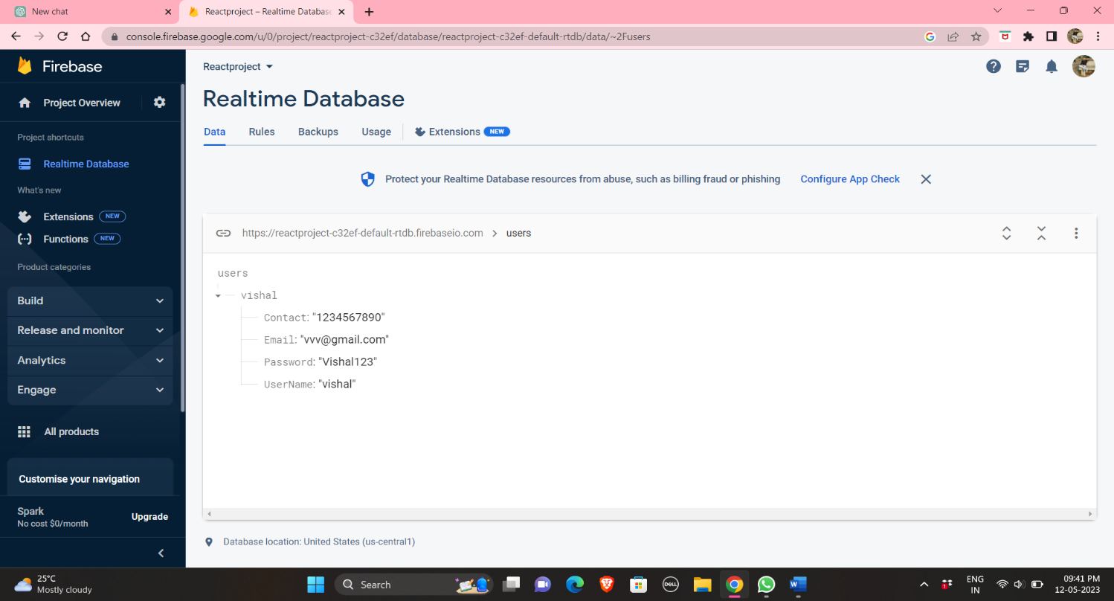

Fig.2. Firebase which Stores Sign up and Login credentials.

1. **Conclusions:**

*In conclusion, the development of Sign up and Login Application using Firebase and React native can provide users with a secure and easy way to manage their passwords. The app can offer features such as password generation, auto-fill, and password storage, making it easier for users to create and manage strong and unique passwords. The user authentication functionality can ensure that the user's data is secure and private, while the dashboard can provide clear and concise overviews of the user's passwords and account information*.

1. **Future Enhancements**

*After the successful completion of the password management app development project using React, there may be opportunities to enhance the app with additional features and functionalities. Some potential future enhancements include:*

1. *Biometric Authentication: Adding biometric authentication such as fingerprint or facial recognition to enhance security and provide a seamless user experience.*
2. *Password Strength Analysis: Implementing a password strength analysis feature to evaluate the strength of passwords and provide suggestions for improving them.*
3. *Dark Mode: Adding a dark mode option for users who prefer a darker interface.*
4. *Password Sharing: Providing a password sharing feature that allows users to securely share passwords with other users or devices.*
5. *Integration with Browser Extensions: Integrating the app with popular browser extensions such as Chrome or Firefox to facilitate seamless password management across multiple devices.*
6. *Two-Factor Authentication: Adding two-factor authentication as an additional layer of security for user accounts.*